**1. You need to enter the total amount of books that one author wrote**

**CREATE OR REPLACE PROCEDURE calculate_total_price (**

**p_unit_price IN NUMBER,**

**p_quantity IN NUMBER,**

**p_total_price OUT NUMBER**

**) AS**

**BEGIN**

**p_total_price := p_unit_price * p_quantity;**

**END;**

**DECLARE**

**price_var NUMBER;**

**quantity_var NUMBER;**

**total NUMBER;**

**BEGIN**

**SELECT price INTO price_var FROM books WHERE author_id = 1;**

**SELECT COUNT(*) INTO quantity_var FROM books WHERE author_id = 1;**

**calculate_total_price(price_var, quantity_var, total);**

**dbms_output.put_line('The total price is ' || total);**

**END;**

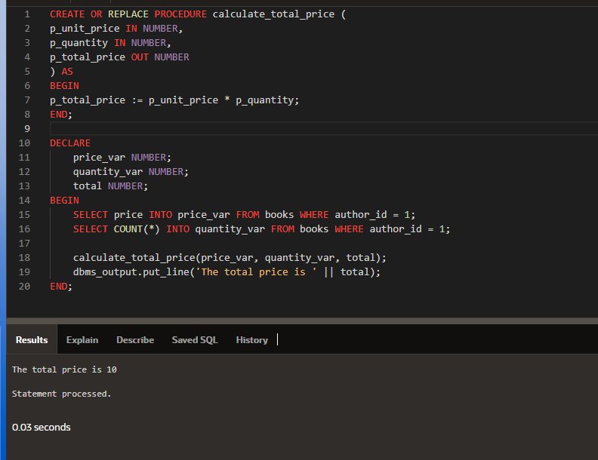

**2.When you receive a new one, you need prices above 1000, otherwise an error will occur. Amount is too small**

CREATE OR REPLACE TRIGGER validate_price

BEFORE INSERT ON books

FOR EACH ROW

BEGIN

IF :NEW.price < 1000 THEN

RAISE_APPLICATION_ERROR(-20001, 'Price too low');

END IF;

END;

INSERT INTO books

(BOOK_ID, AUTHOR_ID, BOOK_NAME, PRICE, BPUB_YEAR, ISBN, COUNT) VALUES (78,

1,'Hunold',999,'02/07/2012',8472938,20)

